

ONE HELL OF A DEAL

Contact:
Scott W. McKinlay | 310-749-9585 | info@detroitriotproductions.com
Paul Travers | 646-715-5001 | paul@bigpicturemediaonline.com
Jim Bartoo | 310-867-5309 | holjim@yahoo.com
Dayna Ghiraldi | 646-467-0524 | dayna@bigpicturemediaonline.com

For legal inquiries
Elsa Ramo | 310.284.3494 |eramo@ramolaw.com
315 South Beverly Drive, Suite 412
Beverly Hills, California 90212


EXECUTIVE SUMMARY


THE OPPORTUNITY – To invest in and be a part of the production of BOIL, a dark spin on the gritty cop thriller with extended potential for licensing & merchandise, soundtracks, and sequels.

LOGLINE – Two Detroit narcotics detectives try to put an end an underground organ ring that preys on Mexican drug mules.

SYNOPSIS – After Detroit narcotics detective Ted McKInlay loses his partner to a meth lab explosion he and his new partner detective Brad Neta take up the case. Brad battles his conscience after transferring from a precinct where he had to testify against his own officers. Now Mexican drug mules are washing up in the Detroit River missing organs and a disgraced doctor has been suspected of performing backroom organ transplants. They need to find the ringleader and stop a woman’s young child from having their organs sold to the highest bidder. The two new partners have to put their trust in each other to bring the underground organ ring down.

THE TEAM – Proven talent, director Scott McKinlay, perhaps best known as the director of Creep Van will direct from the screenplay by Paul Travers who wrote and produced the award winning film, Old 37. Both Paul and Scott will Co-Produce the film. Co-producer Carrie Alton will bring her own unique talents to the team.

THE BUSINESS MODEL – Make a $1.5 million dollar film look, sound, feel and sell like a $25 million dollar movie. We have carefully and seamlessly included high concept story elements, talented, experienced personnel with “name” cast, including at least two top-name talent.
We are creating and producing a unique story that fully capitalizes on our extensive film business experience and our deep professional & social contacts in the Detroit area. We are leveraging our extensive industry contacts in Los Angeles, New York and around the world where the last 25 years has brought us close personal relationships with every facet and category of the film and TV business, including distributors, sales reps, content buyers and studio distribution executives. We are particularly excited about our contacts inside the film festival circuits. Producers intend to leverage a premiere at a top, A-list film festival such as the Austin film festival, SXSW, Gen Art, CMJ, Tribeca or Sundance, (added) Toronto, Cannes and Berlin followed by a relentless push through every possible distribution channel. BOIL’S recognizable cast will be an asset at festivals and conventions throughout the release of the film.

THE PLAN – To use our proven, past successes to assemble a team of very talented individuals whose sum is greater than their parts. With realized modest commercial success with two feature films (GAG, 2007, CREEP VAN, 2012, OLD 37 2015), the plan is now to make something far superior to any of these three ambitious, successful projects. With the knowledge and experience from these three projects and our collective team member’s expertise, our team is energized and confident that we can far surpass our previous success stories. Creep Van grossed $1.3Million on a $140k budget, Gag grossed $210k on a $19k budget and OLD 37 won two best feature awards at HorrorHound and Montreal ComicCon respectively. Three of our films are currently available on Amazon Prime as well multiple DVD, TV, streaming on demand and Video on demand services around the world.

THE INVESTMENT – Fifty (50) “A Class Units” will be issued to investors until $1.5 million is raised. First monies will be paid to Members owning “A Class Units” until they have received an amount equal to 125% of the total Capital Contribution (ROI of 25% is our goal)..
Fifty (50) “B Class Units” will be issued to producers. Lastly, both “A Class Unit” and “B Class Unit” Members receive Fifty (50%) Percent of all net proceeds received by BOIL, LLC from the sale and distribution of the Motion Picture thereafter for 10 years from release date.

THE RISK OF FILM INVESTMENT:

The costs of producing motion pictures are often underestimated and may be increased by reason of factors beyond the control of the LLC or the Manager. Such factors may include weather conditions, illness of technical and artistic personnel, artistic requirements, labor disputes, government regulations, equipment breakdowns and other production disruptions. While the LLC intends to engage production personnel who have demonstrated an ability to complete motion picture projects within the assigned budget, the risk of a project running over budget is always significant and may have a substantial adverse impact on the profitability of any film. The LLC believes the size of the budget for all stages of the Film is sufficient, however, many motion pictures are produced utilizing far larger budgets and still experience cost overruns. The Manager, within its discretion, may secure a ‘Completion Guarantee’ from an established Film Bonding service for the Film produced by the LLC. The cost of this bond shall be included in the budget for the Film.

THE PRODUCING TEAM



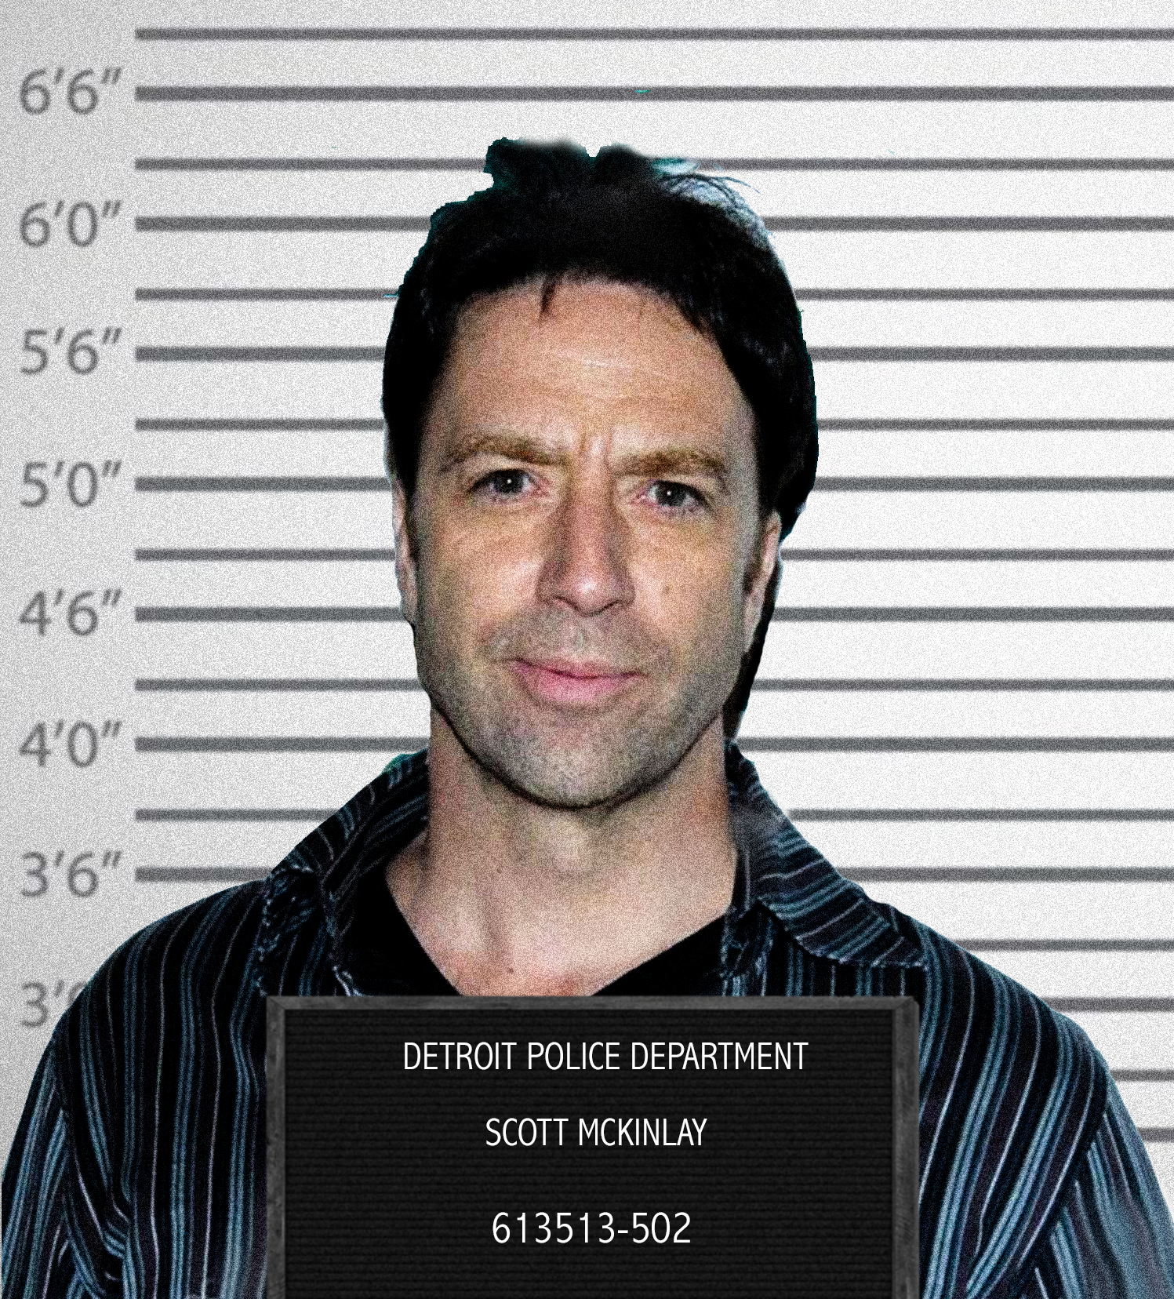





PRODUCTION DETAILS

PRODUCTION DETAILS:

Location – Detroit, MI | Los Angeles, CA
Budget - $1.5 million

PROPOSED SCHEDULE: Spring 2021

PRE-PRODUCTION - 4 WEEKS

Pre-production includes setup and development expenses, casting expenses, first-stage equipment purchases, crew salaries and travel expenses.

PRINCIPAL PHOTOGRAPHY - 4 WEEKS in Detroit and LA

Principal Photography is the process of filming a motion picture and is the most costly stage of production. This includes second-stage equipment purchases and rentals, crew salaries and expenses, location costs and travel expenses.

POST-PRODUCTION - 8 WEEKS

Post-Production includes film editing, score production, final crew salaries and expenses, screening, marketing, distribution, and advertising expenses.

FINAL PHASE - Launch Sales Effort/Industry Screenings & Festival Roll-out. The goal is to have the film ready for a major festival push. The three major festivals we would like to target are Sundance, Cannes and Toronto. These are not only the major selling festivals, where the buyers are, but are also the most heavily attended and publicized festivals in terms of critical exposure for the film.

PREVIOUS PROJECTS

CREEP VAN
Production Budget: $140K
Total Worldwide sales-to-date: $1.3 million

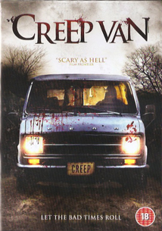
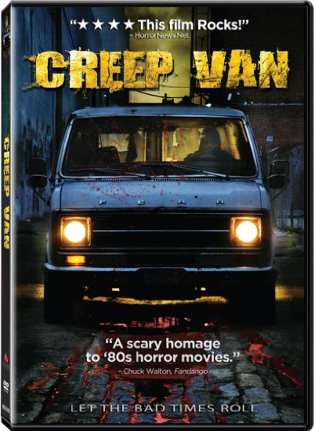

CREEP VAN SOLD WORLD WIDE and is/was available in the following territories/languages:
International:
AUSTRALIA, BENLUX (Belgium, Luxemburg) , CZECH REPUBLIC, GERMANY, MIDDLE EAST, POLAND, CANADA, UNITED KINGDOM, UNITED KINGDOM CBS Television, US Television: CHILLER Network

North America:
Wal-Mart, Best Buy, Netflix, iTunes, RED BOX, Blockbuster, Hastings, Family Video (and more than a dozen other MAJOR North American retailers)
GAG
Production Budget: $19K
Total Worldwide sales-to-date: $210K

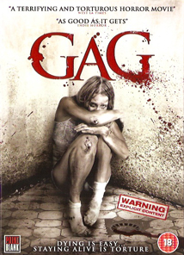


GAG SOLD WORLDWIDE and is/was available in the following territories/languages:
International:
AUSTRALIA, BENLUX (Belgium, Luxemburg), FRANCE, CZECH REPUBLIC, GERMANY, MIDDLE EAST, POLAND, SWEDEN, UNITED KINGDOM, UNITED KINGDOM Television

North America:
Wal-Mart, Best Buy, Netflix, iTunes, Blockbuster, Hollywood Video, Border’s,
Barnes & Noble, FRYS, Family Video + more than 10 other MAJOR North American retailers)



RISK FACTORS

THE PURCHASE OF THE UNITS INVOLVES A HIGH DEGREE OF RISK AND, THEREFORE, SHOULD NOT BE PURCHASED BY ANYONE WHO CANNOT AFFORD THE LOSS OF HIS ENTIRE INVESTMENT. PROSPECTIVE INVESTORS SHOULD CAREFULLY REVIEW AND CONSIDER THE FOLLOWING RISKS AS WELL AS THE OTHER INFORMATION SET FORTH HEREIN:

1. RECENTLY ORGANIZED COMPANY. The Company has recently been organized and therefore has no significant operating history. The Company has no operating revenue and requires the net proceeds of this Offering to produce and distribute the Film. The likelihood of the success of the Company must be considered in light of the problems, delays, risks, expenses and difficulties frequently encountered in connection with the establishment of a new enterprise, many of which may be beyond the Company’s control. The Company is subject to all of the risks inherent in the creation of a new enterprise and the competitive environment in which it will operate. The Company believes that the estimates prepared as to the capital, personnel, equipment and facilities required for its proposed operations are reasonable, but, until the Company’s operations have been fully established, it is not possible to determine the accuracy of such estimates. The Company has not had any significant operating experience to date and therefore has no firm basis, other than management’s opinion, on which to estimate the costs to be incurred.

2. ABSENCE OF IMMEDIATE REVENUES. The Company anticipates that it will incur substantial pre-sale expenses relating to the production and distribution of the Film. The Company currently expects the initial expenses it incurs to result in significant operating losses for the Company since the costs of producing and distributing the Film must be borne by the Company until the Company is able to generate adequate revenues from the sale of the Film, of which there can be no assurance.


3. DEPENDENCE ON AND NEED FOR, ADDITIONAL FINANCING. The Company has very limited resources and is dependent on the proceeds of this Offering or other financing to finance the production of the Film. The Company will be dependent upon receipt of the net proceeds of this Offering to help fund its capital requirements, including the payment of employee’s salaries, and financing the production and distribution of the Film. The Company may not be able to complete the production of the Film if only the Minimum is raised in the Offering. The Manager, however, is currently negotiating the procurement of such funds from various funding sources, including through the pre-sale of certain rights in the Film to distribution companies and other third parties. Rather than delay production of the Film, the Manager has determined to place the Minimum at a lower number and attempt to secure the additional funds required to complete principal photography after the Company has been established. There can be no assurance that the Company will secure such funds or generate sufficient cash flow to satisfy its obligations. Therefore, the Company may require additional financing at any time. The Manager, in his sole discretion, shall have the authority to enter into agreements with third parties for additional financing for the Film; however, there can be no assurance that any such financing can be obtained on terms acceptable to the Company, or at all.

4. COMPETITION. All aspects of the motion picture industry are highly competitive. The Company faces competition from “major” studios and other independent motion picture companies and television production companies not only in attracting creative, business and technical personnel for the production of films, but also in distributing the Film. Many of these competitors have substantially greater experience, assets, financial and other resources than the Company, and have worldwide distribution organizations in place. In addition, the Film will encounter competition from other films and other types of public entertainment. The competition faced by motion picture theaters for the public’s leisure-time activities has increased in recent years due to the expansion of the number of entertainment outlets such as cable and video. Revenues from licensing motion pictures to foreign and domestic pay television, videocassettes, and videodiscs have increased while domestic network television fees have decreased. The revenues from the sale of videocassettes and videodiscs are sometimes adversely affected by unauthorized duplication practices.



5. DEPENDENCE ON MANAGEMENT; LIMITED AVAILABILITY OF MANAGEMENT. The Company’s success will be largely dependent upon the continued employment and personal efforts of Scott McKinlay and Paul Travers and other associated parties as approved by the Managers. The aforementioned parties do not currently devote all of their time to the Company’s business and are currently involved in other film, theater and entertainment related ventures. The loss of the services of any of the aforementioned parties would have a materially adverse effect on the Company’s business and prospects for the future. If one or more of the aforementioned parties should become incapacitated or otherwise unavailable, a qualified successor would have to be employed and there can be no assurance that the Company would be able to employ personnel having the same degree of talent and/or experience. The success of the Company will also be dependent upon its ability to hire and retain additional qualified personnel with experience in the motion picture industry. The competition for such personnel is intense. There can be no assurance that the Company will be able to hire or retain such necessary personnel. Failure to do so would have a materially adverse effect on its business.

6. BENEFITS TO EMPLOYEES. The Managers shall receive payment in the amount of Ten Thousand Dollars ($10,000) for development costs incurred by the Managers.

7. LIMITED TRANSFERABILITY OF UNITS; LACK OF TRADING MARKET. Purchasers of the Units must be aware of the long-term nature of their investment and be able to bear the economic risks of their investment for an indefinite period of time. No trading market exists for the Units and none is expected to develop. None of the Units have been registered under the Act, or under the securities laws of any state. The right of any purchaser to sell, transfer, pledge or otherwise dispose of the Units will be limited by the Act and state securities laws and the regulations promulgated there under. Consequently, if as a result of some change in circumstances arising from an event not presently contemplated, a purchaser wishes to transfer some or all of his Units, he may find such transfer difficult or impossible to effect. Prospective investors should be able to afford the entire loss of their investment in the Company.

8. CONTROL OF THE COMPANY. The operations of the project will be directed by the Managers. Scott McKinlay and Paul Travers are the Managers of the project.

9. OFFERING PRICE. The offering price of the Units has been determined by the Company, and bears no relationship to the Company’s assets, book value, potential earnings, net worth or any other recognized criteria of value. The offering price does, however, bear a relation to the estimated costs of producing the Film.

10. BROAD DISCRETION IN APPLICATION OF PROCEEDS. A substantial portion of the net proceeds of this Offering will be applied to the production, distribution and exploitation of the Film as well as general corporate purposes. Accordingly, the Company’s management will have broad discretion as to the application of such proceeds. Moreover, the Company intends to maintain flexibility in order to adjust its strategies in response to changes in the motion picture industry.

11. NO TAX OPINION. Neither the Company nor counsel to the Company will render any tax opinion or advice with respect to this Offering. Accordingly, each investor should discuss the tax considerations of an investment in the Units as it relates to him with his own tax advisor.



12. TAX RISKS. It is the intent of the Manager to file tax returns for the Company as a limited liability company; however, no ruling has been applied for from the Internal Revenue Service that the Company will be treated as a limited liability corporation for federal income tax purposes and not as an association taxable as a corporation. There is no assurance that such treatment will, in fact, be accorded the Company. If the Company were treated as a corporation for federal income tax purposes, the Company’s income would be subject to tax at the entity level, and distributions made from the Company earnings would again be taxable as dividend income to the Members. In addition, Company tax losses (if any) could not be deducted by the Members. Thus, an Investor’s economic return on an investment in Units could be substantially reduced if the Company were taxed as a corporation for federal income tax purposes. Each Investor will be required to report on his or her own federal income tax return for each taxable year his or her distributive share of Company taxable income or loss attributable to the Company’s taxable year ending with or within such taxable year. Each Investor will be subject to tax on his or her distributive share of Company taxable income regardless of whether an actual distribution of cash or other property is made by the Company to such Investor.
THE FOREGOING ANALYSIS IS NOT INTENDED AS A SUBSTITUTE FOR CAREFUL TAX PLANNING. THE TAX MATTERS RELATING TO THE COMPANY AND THE TRANSACTIONS DESCRIBED HEREIN ARE COMPLEX AND ARE SUBJECT TO VARYING INTERPRETATIONS. MOREOVER, THE EFFECT OF EXISTING INCOME TAX LAWS AND POSSIBLE CHANGES IN SUCH LAWS WILL VARY WITH THE PARTICULAR CIRCUMSTANCES OF EACH INVESTOR. EACH PROSPECTIVE INVESTOR SHOULD CONSULT WITH AND RELY ON HIS OR HER OWN ADVISORS WITH RESPECT TO THE POSSIBLE TAX CONSEQUENCES, INCLUDING RISKS AND ADVANTAGES (FEDERAL, STATE AND LOCAL) OF AN INVESTMENT IN THE COMPANY, AND, IN THAT REGARD, EACH SUCH PROSPECTIVE INVESTOR SHOULD NOT RELY IN ANY WAY ON ANY TAX INFORMATION HEREIN CONTAINED.

13. NO GUARANTEE OF RETURN. No assurance can be made or is given that a purchaser of Units will realize a substantial return on his investment or any return at all or that he will not lose his entire investment. For this reason, each prospective investor should read this Offering Memorandum and all exhibits carefully and should consult with his own attorney, accountant or business advisor prior to making an investment decision.

14. RISKS OF MOTION PICTURE PRODUCTION. The production of motion pictures involves a substantial degree of risk. The costs of producing a film are often miscalculated and may be increased by reasons or factors beyond the control or present knowledge of the Company (such as delays caused by labor disputes, illness, accidents, strikes, faulty equipment, destruction or damage to the film itself, or bad weather), so that the Company may require additional funds in order to complete the production. All funds invested in the Film may be lost if the production is stopped or abandoned for reasons not covered by insurance. The Company will seek to obtain customary production insurance for the Film, which will protect the Company against most of these risks. However, it is not possible to insure against all risks, and sometimes it may not be possible to continue production even though the Company receives insurance proceeds. The Manager has made provision in the budget for at least a Ten percent (10%) contingency fund to cover unforeseen costs in connection with the production of the Film. As an additional risk reduction measure, the Manager reserves the right to obtain a completion bond in connection with the production of the Film, if available, pursuant to which any production cost overruns would be guaranteed by the bonding company. The Company believes it can limit its overall financial exposure by engaging in a rigorous pre-investment analysis of the potential commercial viability of the Film prior to making financial commitments. The Company will monitor the production and direction of the Film closely to confirm adherence with budgets, and will take direct control of the Film’s production if budget overruns occur.

15. RISKS OF MOTION PICTURE DISTRIBUTION. The success of the Company in its distribution activities will depend on a number of factors over which the Company will have little or no control. Even if the Film is an artistic or critical success, there can still be no assurance that distribution will succeed on an economic level. The process of distributing a motion picture is costly and entails commercial problems, which could adversely affect the Company’s ultimate profitability, including: public taste, which is unpredictable and susceptible to change, competition for theaters, competition with other films and other leisure activities, advertising costs, uncertainty with respect to release dates, and the failure of other parties to fulfill their contractual obligations and other contingencies. While box office receipts have been relatively stable, the costs of producing films, making prints required for exhibition, and the advertising necessary to promote and market films, have increased substantially. Costs associated with creative and artistic personnel have also increased in certain instances. The combination of these factors has caused the proportion of unprofitable films in the industry to increase. In the event that a film is distributed in foreign countries, some or all of the revenues derived from such distribution may be subject to currency controls and other restrictions, which would restrict the available funds.

16. DEVELOPMENTS IN THE MOTION PICTURE INDUSTRY. In recent years, in order to recoup production costs, it has become increasingly important to exploit a motion picture in ancillary markets, which include domestic and foreign pay television, network television, DVD and streaming video. These markets represent the fastest growing segment of a film’s potential revenue sources. The successful exploitation of a motion picture in ancillary markets is often dependent on the success of its initial theatrical distribution. Therefore, it is important for a film to do well in its initial theatrical distribution. If it does not, the ability of the Company to exploit it in ancillary markets may be limited.

17. DISTRIBUTION CONTRACT. Once the distributor distributes the Film, there is no assurance that the Film will be an economic success even if it is successful critically or artistically, or both. Distribution agreements generally give a distributor significant flexibility in determining how a film will be exhibited. There can be no assurance that the distributor will not limit the Film’s run, limit the territories in which the Film is exhibited or otherwise fail to actively promote the Film. Any such action by the distributor could have a materially adverse effect on the economic success of the Film and revenues received by the Company. There can be no assurance of ancillary or foreign sales of the Film. In any event, Net Profits cannot be realized if at all, until many months after the Company’s expenditure of the Member’s investment.

18. LICENSES. A portion of the Company’s business may consist of licensing musical recordings from other companies for use in connection with a film soundtrack, which may ultimately be included on an album produced by the Manager. These companies may refuse to license recordings to the Company because they wish to exploit these recordings themselves, or they may request unfavorable royalty commitments from the Company. The Company’s right to exploit recording licenses will generally be subject to restrictions, such as limiting distribution to particular markets. There can be no assurance that the Company will be able to obtain licenses of other companies’ recording artists on terms satisfactory to the Company, if at all.

19. POST PRODUCTION COSTS. If the proceeds of the offering do not exceed the Minimum, the Company may be unable to complete the editing and post-production work necessary to complete the Film. In such event, the Company may have to enter into an agreement with third parties, preferably a distribution company, to provide “finishing funds” for the Film. Though such arrangements are standard in the independent film industry, relying on third parties for the provision of such funds may require the Company to enter into a compensation agreement, which is favorable to such third parties, and may ultimately dilute the market potential of the Film.

20. IMPORTANT AGREEMENTS NOT YET CONCLUDED. The Manager has not yet concluded agreements for the employment of outside producers, certain other key personnel or for the distribution of the Film. A failure to conclude such agreements may delay or permanently forestall the production of the Film.

21. DEFERRALS. The Company may arrange for services to be provided to the Company for the production and distribution of the Film for which reduced or no compensation will be initially required, it being understood that the provider of such services will be compensated by the Company for the value of such services from the Cash Flow of the Company in accordance with the provisions of the LLC Operating Agreement. The value of such Deferrals shall be negotiated and documented by the Manager prior to the provision of such services to the Company, and shall not exceed Two Hundred Fifty Thousand Dollars ($250,000) in the aggregate.

22. SALE OF TERRITORIAL DISTRIBUTION RIGHTS. On behalf of the company, the Manager has reserved the right to sell the distribution rights, at any time, to the Film in any territory, which it, in its sole discretion, deems appropriate. The sale of such rights shall be for fair value and in accordance with the standards and practices of the motion picture industry. The revenues from such a sale, however, may be considered Gross Receipts of the Company and/or may be attributed to the capitalization of the Company. Such agreements shall not affect the Members’ priority of distribution of Cash Flow, and although such agreements may increase the Member’s participation percentage, the sale of the right to exploit the Film in certain territories might ultimately dilute the market potential for the Film.

23. THIRD PARTY PROFIT PARTICIPATIONS. The Manager has reserved the right to grant profit participations to certain third parties in order to obtain their services.

PUBLICITY PLAN


PUBLICITY PLAN - Big Picture Media will be instrumental in creating awareness of BOIL. All of our campaigns are tailored specifically for each film, and we’re known throughout the media for our genuine enthusiasm for our clients in addition to providing dedication and commitment in introducing press to the best of film. Our plan targets both national and regional print, television, syndicated radio and online outlets, across the country and internationally when ready.

Our plan is as follows:

OBJECTIVES

The overall public relations objectives for the campaign are to:
• Craft and implement a creative publicity strategy and viral marketing campaign to create awareness of BOIL nationwide to drive people to see the film and impact box office numbers for each city the film will be playing.
• Create thorough social network (instagram, facebook, variety, deadline, etc)
• Work closely, honestly and as a team with the crew of BOIL to make sure we are adequately representing the film in our outreach to the press. All materials generated by BPM pend client approval (i.e. press releases, overviews, etc).
• Secure profile pieces in national publications and film trades on screenwriter and director.

STRATEGY

• Work in coordination with BOIL crew and actors willing to speak to press.
• Outreach to film targets, as well as alternative weeklies, newspapers and broadcast (TV and Radio). Set up interviews with cast and crew, as requested.
• Determine premiere party logistics and details. Develop a red carpet event for NY/LA/MI premiere of movie
• Photo Wires
• Determination of actors in attendance
• Invites out to press and attendees
• RSVP list developed
• Coordinate with the premiere theatre to determine their premiere outreach efforts.

Big Picture Media is a full service entertainment PR agency based in NYC.











COMPARABLE PROJECTS



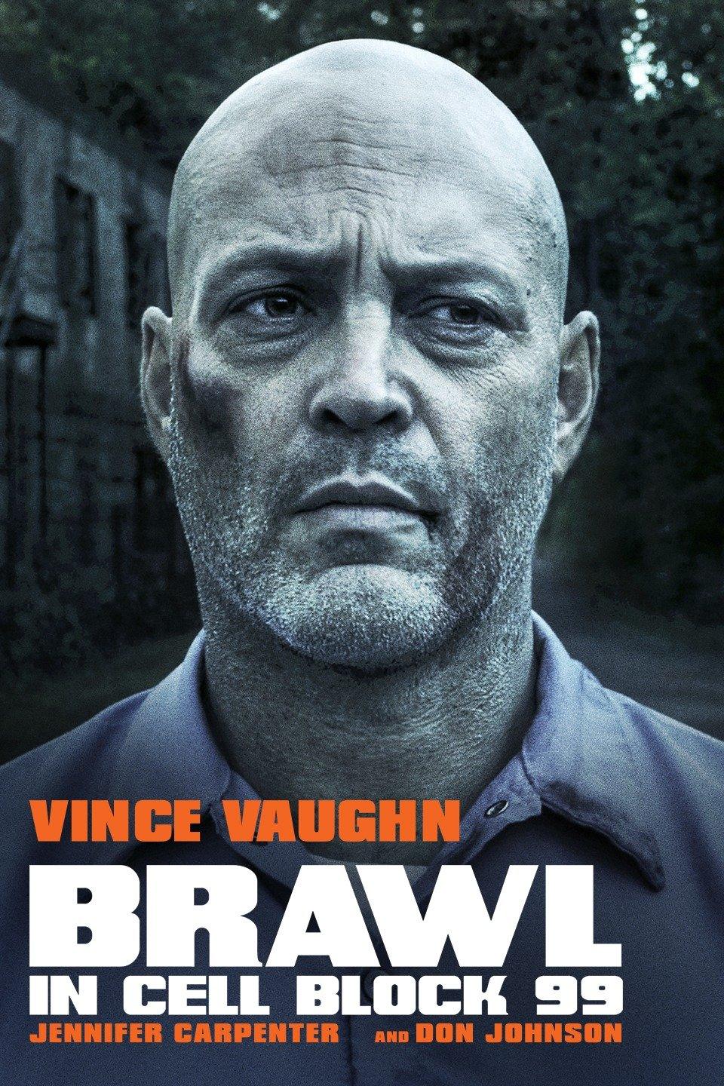

Director: S. Craig Zahler
Year: 2017
Budget: n/a
Production Company: Assemble Media/Cinestate
Starring: Vince Vaughn, Don Johnson
Distribution: RLJE Films



Director: John McDonagh
Year: 2016
Budget: n/a
Production Company: Bankside Films
Starring: Alexander Skarsgard, Michael Pena
Distribution: Saban Films



Director: S. Craig Zahler
Year: 2019
Budget: n/a
Production Company: Unified Pictures
Starring: Vince Vaughn, Mel Gibson
Distribution: Summit Ent

DISCLAIMER AND TERMS OF USE:

Prospective Purchasers should be aware that purchase of these securities involves a high degree of risk, and should be considered only by those people who have no need for liquidity and can afford the entire loss of the investment. Furthermore, each prospective purchaser may be required to bear the economic risk of this investment for an indefinite period of time. The offering and sale of the LLC securities described herein are not being offered under the Federal Securities Act of 1933, as amended, or under any state’s securities act, but rather are being exempted from such registration as provided by law. Therefore, units of the LLC securities described herein which are purchased by an investor may not be sold, transferred, hypothecated or otherwise disposed of by that investor unless such units are so registered, or in the opinion of management’s counsel, exemptions from registration are available. The LLC securities described herein have not been approved or disapproved by the Securities and Exchange Commission (SEC) nor any state securities commission, and no such commission has passed upon or endorsed the merits of this offering. Any representation to the contrary is a criminal offense.

PROSPECTIVE PURCHASERS:

Each prospective purchaser and his or her representative may make inquiries of the manager with respect to the business or any other matters relating to the manager and an investment in the securities thereof. He or she may obtain any additional information, which such prospective purchaser deems necessary, in connection with making an investment decision in order to verify the accuracy of the information contained in this proposal (to the extent that the LLC possesses such information or can acquire it without unreasonable effort or expense). In connection with any such inquiry, any documents, which any prospective purchaser wishes to review, will be made available for inspection and copying or provided, upon request, subject to the prospective purchaser’s agreement to maintain such information in confidence, and to return the same to the manager if the recipient does not purchase the securities offered hereunder. Any such inquiries or requests for any such additional information or documents should be made in writing to the manager. Prospective purchasers are not to construe the contents of this proposal as legal, investment or tax advice. Prospective purchasers should consult their advisors as to legal, investment, tax and other related matters concerning an investment by such prospective purchaser in the LLC. Each prospective purchaser should be aware that the prospective purchaser may be required to bear the economic risk of this investment for an indefinite period of time. The units offered hereby have not been registered under the Federal Securities Act of 1933, as amended, and therefore cannot be sold unless so registered or an exemption from registration is available. Accordingly, in determining whether a prospective purchaser can bear the economic risk of this investment, a prospective purchaser should consider, among other factors, whether such prospective purchaser can afford to hold such unit interests for an indefinite period, and whether at the time of the investment, such prospective purchaser can afford a complete loss of his or her investment.

THE RISK OF FILM INVESTMENT:

The costs of producing motion pictures are often underestimated and may be increased by reason of factors beyond the control of the LLC or the Manager. Such factors may include weather conditions, illness of technical and artistic personnel, artistic requirements, labor disputes, government regulations, equipment breakdowns and other production disruptions. While the LLC intends to engage production personnel who have demonstrated an ability to complete motion picture projects within the assigned budget, the risk of a project running over budget is always significant and may have a substantial adverse impact on the profitability of any film. The LLC believes the size of the budget for all stages of the Film is sufficient; however, many motion pictures are produced utilizing far larger budgets and still experience cost overruns. The Manager, within its discretion, may secure a ‘Completion Guarantee’ from an established Film Bonding service for the Film produced by the LLC. The cost of this bond shall be included in the budget for the Film.

THANK YOU FOR YOUR INTEREST

